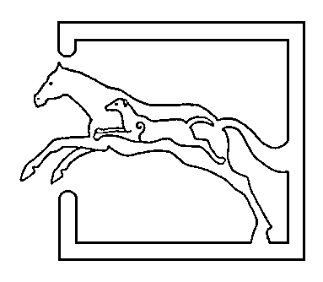
39 Gordon Street, Huntly, Aberdeenshire AB54 8EQ

Telephone: 01466 792627 Fax: 01466 794962

VETERINARY SURGEONS
STRATHBOGIE VETERINARY CENTRE LTD

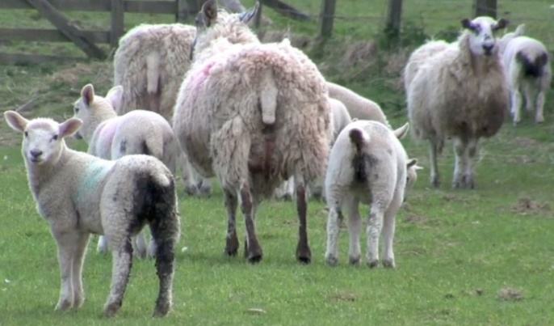With the very mild spring that we have had, we have already seen some cases of Nemotidirus. As you are aware, this is a small intestinal parasite affecting young lambs (from 5-6 weeks old). Clinical signs to watch out for are; scouring, loss of appetite and sudden death. If you notice any lambs scouring then prompt treatment is essential.... Treatment for Nemotidirus is a white drench (Benzimidazoles) If possible, keeping lambs off grass grazing grazed the previous year by young lambs as this is a lamb-lamb parasite. A faecal sample can be useful to establish if any other parasitic causes of scour are present – i.e. co-infections of nematodirus and coccidiosis are common. As many of you know we can see under the microscope if coccidiosis is present, however there are some species which do not cause clinical disease. Lab analysis can establish if the coccidia are a dangerous type (pathogenic) or a non if they are non dangerous type of coccidia. However if losses and scouring is present then the advice is usually to treat before waiting for a lab result. Whilst on the topic of sudden death in lambs.... back to clostridial disease. Lambs from vaccinated ewes will have some immunity to these diseases (if adequate colostrum has been absorbed at birth) however vaccination from 3 weeks age is required to boost immunity and another injection 4-6 weeks after to obtain optimal immunity. There was an increase in the number of cases of clostridial disease last summer due to the dry weather. This caused the animals to graze lower so it really is something that we recommend doing. Usually the larger well growing lambs are the ones which succumb to these diseases and for the cost of the vaccine it really is worthwhile!
This spring we have seen many cases of sheep abortions especially from non vaccinated flocks. Some of these have been from closed flocks. We assume that wildlife carriers of infected tissues are partially to blame for this. Until the end of July, MSD are offering FREE LAB FEES (blood sampling fee (+/- visit) still applicable) for UNVACCINATED flocks for ewes which have aborted, or if you have had increased numbers of barren ewes. Please speak to any of the vets if you would like to discuss this further.

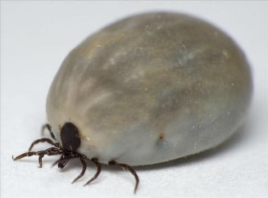We have seen many creepy crawlies on all species of animals this year due to the milder winter/spring. Therefore the use of ecto-parasite control may be warranted earlier this year. Although we haven’t seen cases as yet it is only a matter of time until flystrike causes problems amongst the sheep. When applying pour ons etc double check withdrawal periods for sending fat lambs away. For prices for these treatments please speak to Anthea or Michelle.

A few jokes for you… chosen by Mr Brown!

Two farmers were discussing the weather. Said the first, ‘Man, that shower will do a lot of good,it’ll bring things out o’ the ground.’
‘God forbid’, said his neighbour, I’ve three wives there!’

‘There are times when parenthood seems nothing but feedings the mouth that bites you’ AC Swinburne

‘Teach your child to hold his tongue: he’ll learn fast enough to speak’ B Franklin

‘Fit dae Aberdonians dae when its gae cauld? Sit roon a candle. And when its gae gae cauld? They light it!’

What do you call a Glaswegian in a suit?
The accused
In a 4 bedroom house?
A Burglar!

Voter to politician – ‘ Tell me as an outsider what do you think of the human race?’

